STEM Ambassadors: logging activities
In order for us demonstrate the value and impact of the STEM Ambassadors programme it’s important for us to capture as much as we can about your volunteering; all STEM Ambassador activity needs to have been recorded on the platform.
Any activity you register for via the STEM Ambassador dashboard is recorded automatically so you don’t need to do anything further.
However, if you arranged the activity outside the STEM Ambassador dashboard, such as through your company, or with a local school through your own networks, you will need to log it. This ensures you are credited for the number of hours you volunteer and allows us, as a funded initiative, to evaluate the effectiveness and impact of the programme nationwide.
From your dashboard, click on the ‘Activities’ heading on the left menu to expand it, then click ‘Add activity’ or click the ‘Add an Activity’ on your dashboard page.
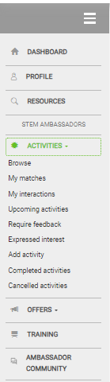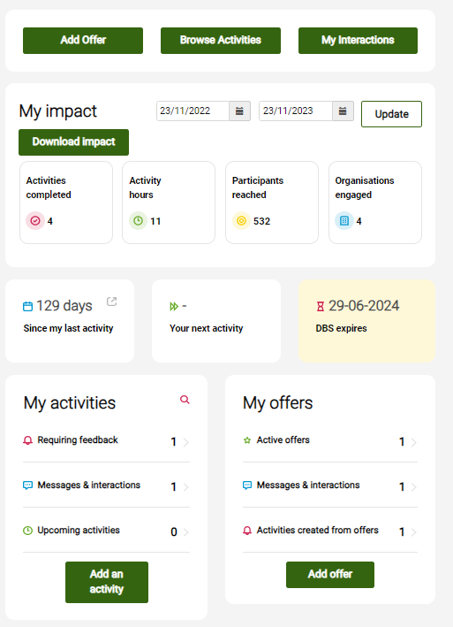

Only STEM Ambassadors with an approved DBS/PVG will be able to add a completed activity.

Then fill out the activity form:
1. Provide an informative title and brief description of the activity that you carried out. Try to capture the activity type as closely as possible so your record is accurate. Unless the activity was related to a scheme that you are part of, you do not need to enter anything here. | 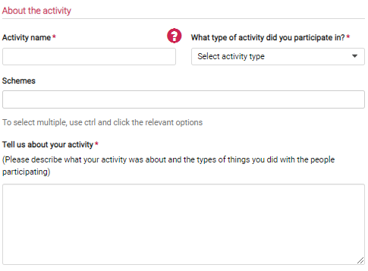
2. Either tick ‘Online’ or use the address lookup to add the venue for the activity. Once you have found the address, click ‘Select Address’ to populate the details. If the postcode is not picking up any addresses, please fill it in manually and select the relevant local authority from the presented list. | 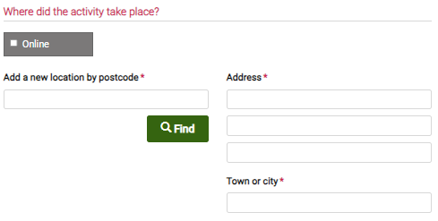
3. If you know which schools or organisations participated, add them here. Start typing the name and then click on the relevant details to add them. If the organisation is not in the list, please leave this section blank. | 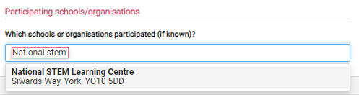
4. Tell us when the activity took place, how many hours it was and how long you spent preparing for the activity. If you have spent multiple hours on different dates doing an activity eg. a STEM Club, for ease you can log a month’s worth at a time. We advise you choose a date in the middle of the range and log all the hours to this date. | 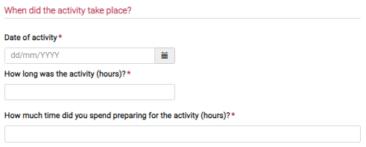
5. Tell us about the activity audience, who they were and the number of participants. | 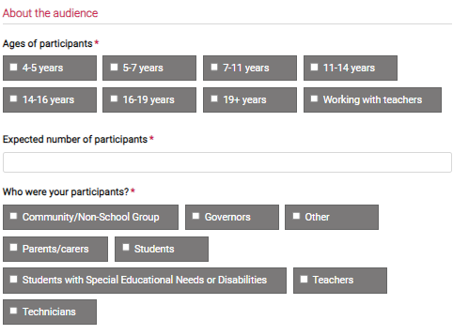

Once you’re happy with the details, click 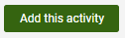

This will be added on your record, and your volunteer hours will be counted. To see a list of your completed activities, click on the ‘Completed activities’ section on your menu.
We are keen to reward active STEM Ambassadors, recognising their contribution to encouraging and inspiring young people in STEM subjects. There are a variety of ways we do this including giving awards throughout the year, and a digital badges to celebrate your involvement in the programme. We can only do this accurately if you record your activities, so thank you for taking the time to do this.

If you would like any further support, contact us at stem-ambassadors@stem.org.uk

